a)

**Dodge and Cox Balanced Fund (DODBX) 2013-09-01 to 2016-09-01**

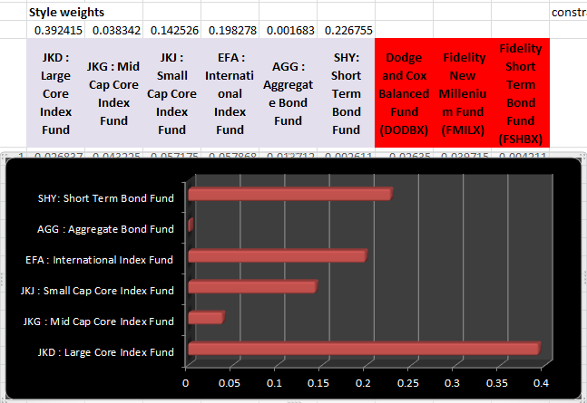

The Return-Based Style Analysis reveals that, DDBX Fund’s benchmark portfolio allocates 39.24% on large cap stocks, 3.83% on mid cap stocks, 14.25% on small cap stocks, 19.83% on international index fund(equity market performance in developed and emerging markets, excluding US), almost none (0.17%) on aggregated bond fund (including government securities, mortgage-backed securities, asset-backed securities and corporate securities), and 22.68% on short term bonds.

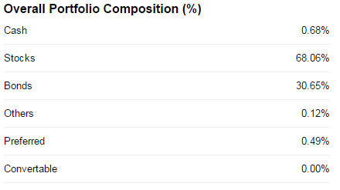

The portfolio composition reported on finance.yahoo.com differs with the RBSA results, some degree but not a lot. In terms of stocks, RBSA: 77.15% vs Yahoo: 68.06%; in terms of bonds, RBSA: 22.85% vs Yahoo: 30.65%. RBSA suggests higher stocks and lower bonds.

**Fidelity New Millenium Fund (FMILX)**

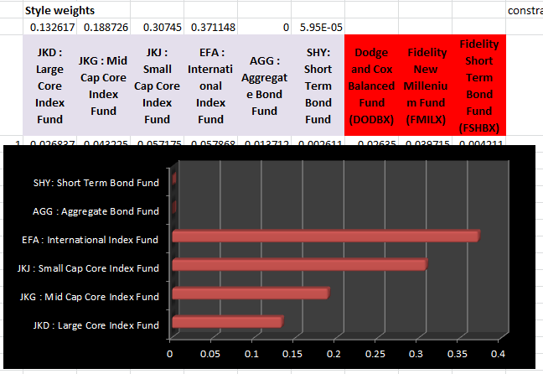

The Return-Based Style Analysis reveals that, DDBX Fund’s benchmark portfolio allocates 13.26% on large cap stocks, 18.87% on mid cap stocks, 30.75% on small cap stocks, 37.11% on international index fund, none on aggregated bond fund, and almost none (<0.01%) on short term bonds.

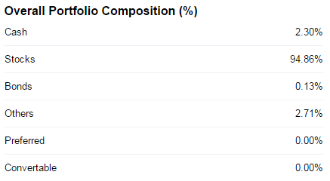

The portfolio composition reported on finance.yahoo.com mostly agrees with the RBSA results. In terms of stocks, RBSA: 99.99% vs Yahoo: 94.86%; in terms of bonds, RBSA: <0.01% vs Yahoo: 0.13%. RBSA suggests slightly higher stocks and slightly lower bonds.

**Fidelity Short Term Bond Fund (FSHBX)**

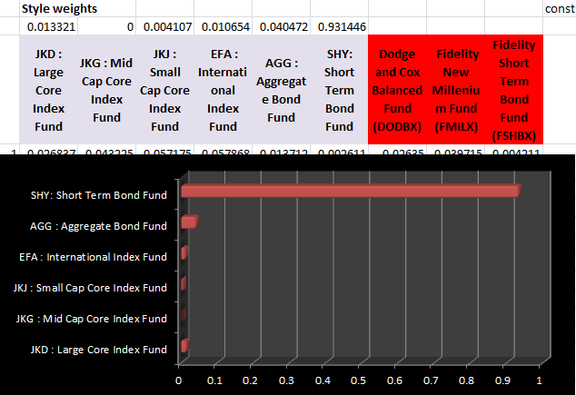

The Return-Based Style Analysis reveals that, DDBX Fund’s benchmark portfolio allocates 1.33% on large cap stocks, 0% on mid cap stocks, 0.41% on small cap stocks, 1.07% on international index fund, 4.05% on aggregated bond fund, and 93.14% on short term bonds.

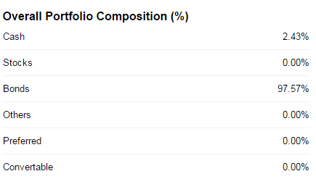

The portfolio composition reported on finance.yahoo.com is almost the same as the RBSA results. In terms of stocks, RBSA: 2.81% vs Yahoo: 0%; in terms of bonds, RBSA: 97.17% vs Yahoo: 97.57%. RBSA suggests slightly higher stocks and slightly lower bonds.

b)

**Dodge and Cox Balanced Fund (DODBX) 2010-09-01 to 2013-09-01**

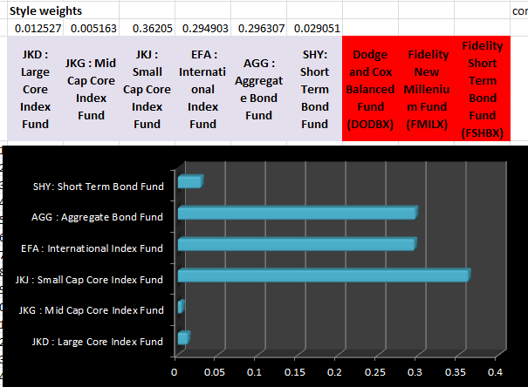

**Dodge and Cox Balanced Fund (DODBX) 2013-09-01 to 2016-09-01**



Compare the two periods, we see a large shift from AGG, EFA, and JKL to SHY and JKD, it might suggest a shift to US large cap company investment strategy after 2013, while before more investment on bonds, international equity, and small cap company.

**Fidelity New Millenium Fund (FMILX) 2010-09-01 to 2013-09-01**

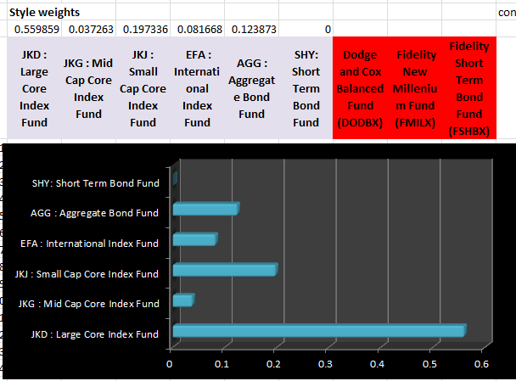

**Fidelity New Millenium Fund (FMILX) 2013-09-01 to 2016-09-01**



Compare the two periods, we see a large shift from JKD to EFA, JKJ and JKD, it might suggest a shift to emerging market equity, US small and mid cap company investment strategy after 2013, while before more investment on US large cap company.

**Fidelity Short Term Bond Fund (FSHBX) 2010-09-01 to 2013-09-01**

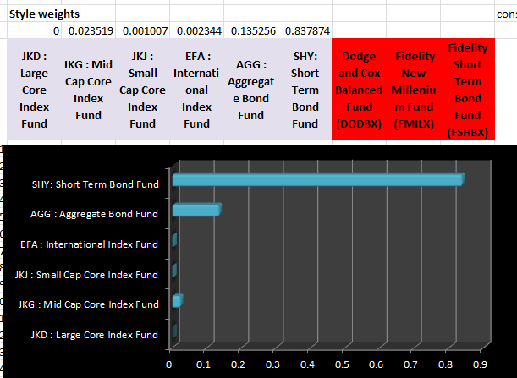

**Fidelity Short Term Bond Fund (FSHBX) 2013-09-01 to 2016-09-01**



Compare the two periods, we see a quite consistent investment strategy, which is mostly on bonds, almost none on stocks. Exactly what the name of the fund suggests.